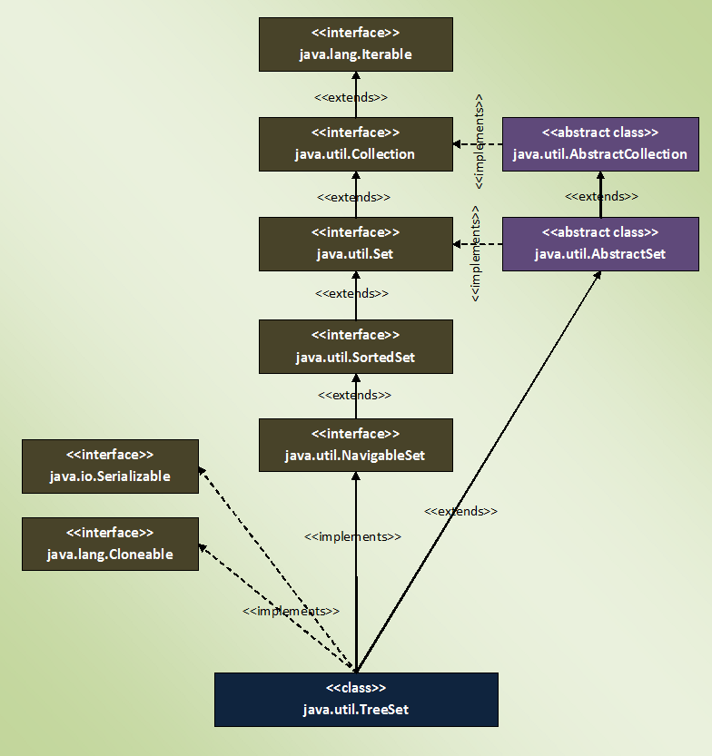

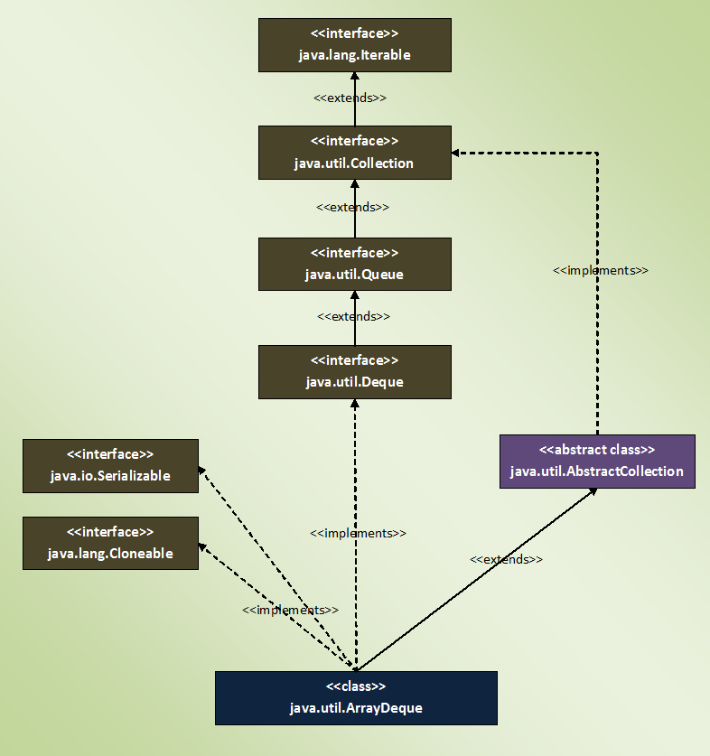

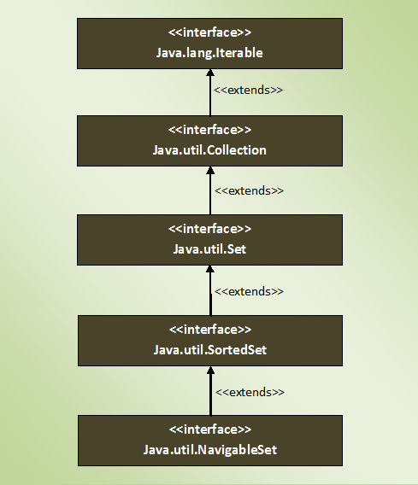

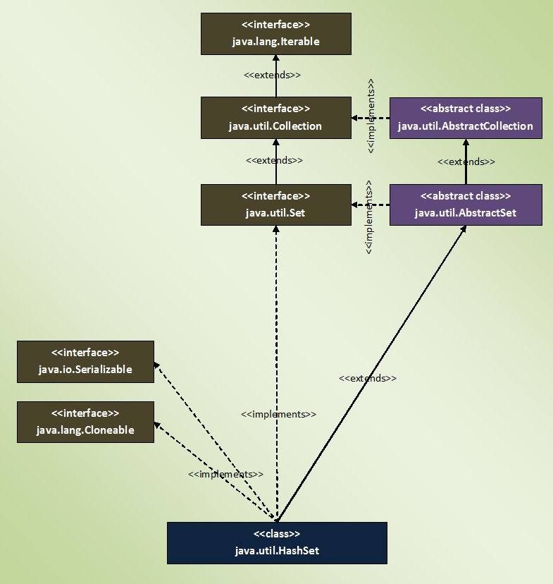

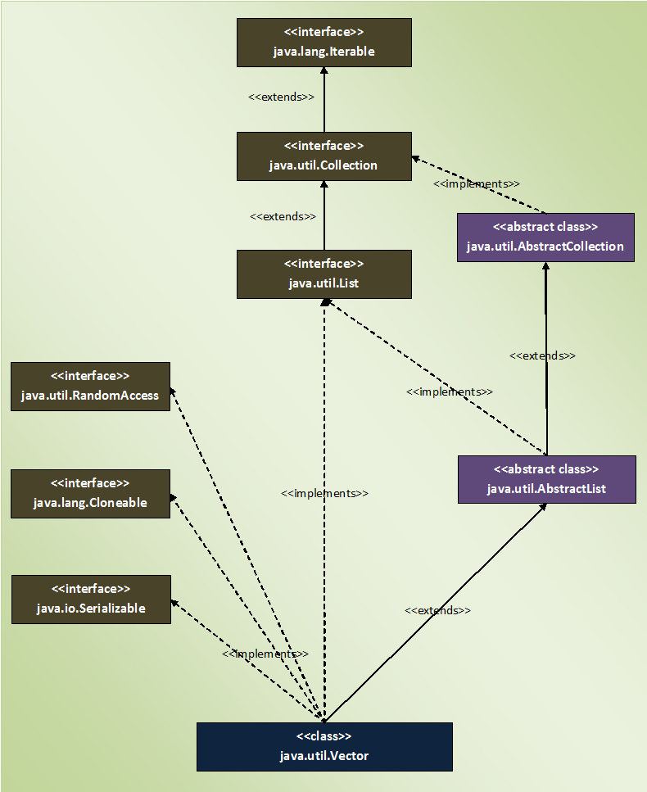

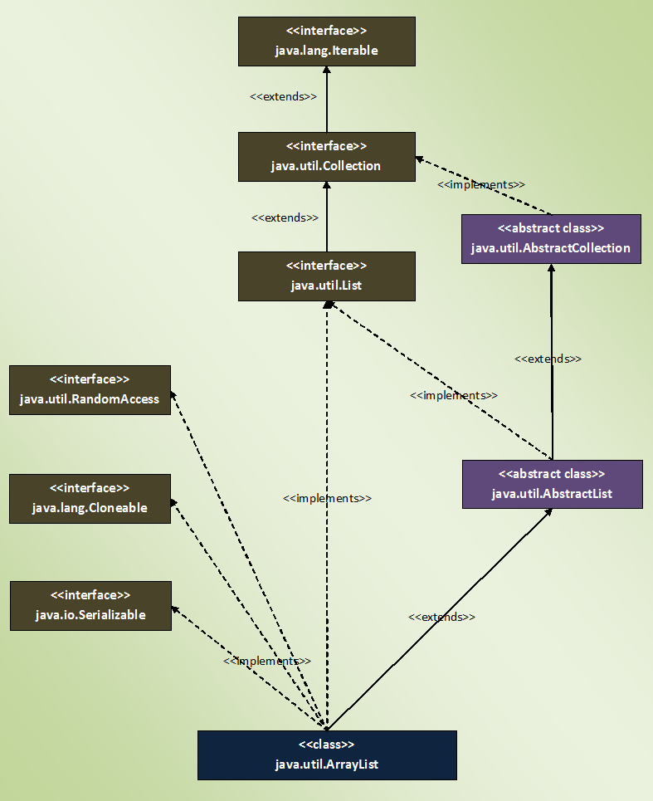

Limitations of arrays:

1. Fixed in size
2. Homogenous
3. No underlying Data structure: no readymade methods support

To overcome these limitations, we go for collections.

Collections:

1. Growable in nature
2. Can hold both homogenous and heterogenous elements
3. Every class is implemented on some standard data structure, hence readymade methods are available.

**If we know size in advance it is suggestable to go for Array which improves the performance.**

**In collections we can hold objects not primitives.**

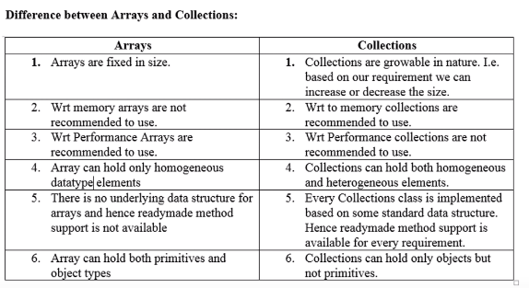

**Collection:** Is a group of individual objects that represent as a single entity.

**Collection Framework:** It defines several classes and interfaces that can be used to represent collection.

**9 Key Interfaces of Collection Framework:**

1. **Collection:** It has the most common methods which are applicable by any collection object.

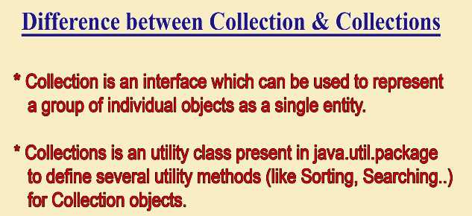

1. **List:**  used when duplicates are allowed, and insertions order preserved.

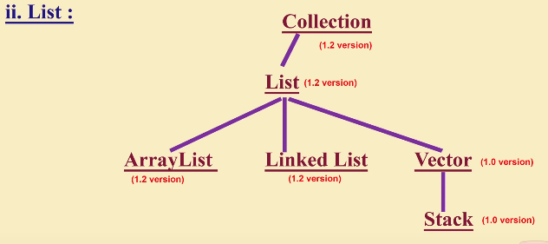

1. **Set:** used when duplicates are not allowed, and insertion order is not preserved.
2. **SortedSet:** where duplicates or not allowed, bit objects should be inserted according to some sorted order.
3. **NavigaleSet:** It defines several methods for navigation purposes.
4. **Queue:** If we want to represent a group of individual objects prior to processing.
5. **Map:**  not child interface of collection. If we want to represent a group of individual objects as key value pairs. No duplicate keys are allowed.

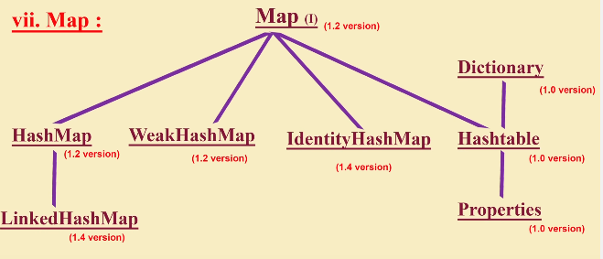

1. **SortedMap:** When we want to represent a group of key value pairs according to some sorting order of keys.
2. **NavigableMap:** defines several methods for navigation purposes.

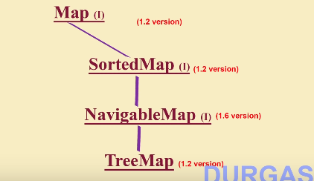

**For Sorting**:

Comparable(I): default nature of sorting order.

Comparator(I): customized sorting.

**Cursors**: For getting objects of collections

1. Enumeration(I)
2. Iterator(I)
3. ListIterator(I)

**Utility classes**: Collections and Arrays.

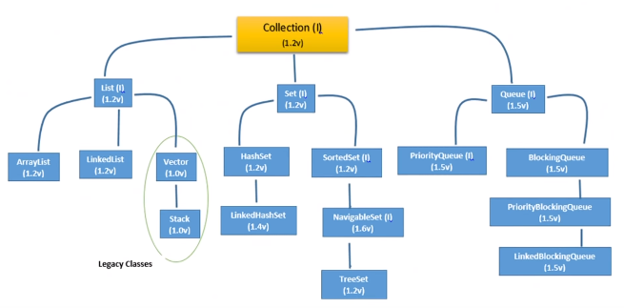

**Methods of Collection Interface:**

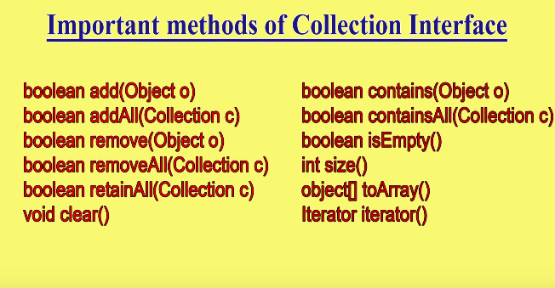

Collection Interface doesn’t contain any method to retrieve objects.

**Methods of List Interface:(all methods deals with index)**

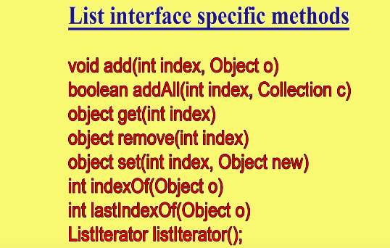

**ArrayList:**

1. Underlying Ds for Arraylist is Growable array or Resizable Array.
2. Duplicates allowed.
3. Insertion order preserved.
4. Heterogenous Objects allowed. (Except Treeset and TreeMap not allowed)
5. Null insertion possible.

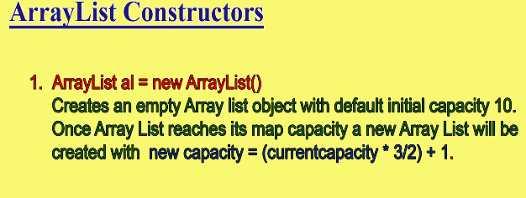

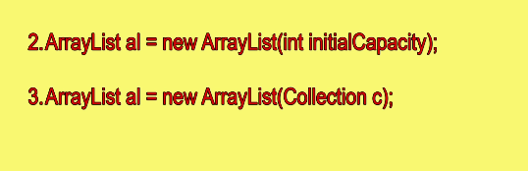

**Note: Every collection object implements Serializable (**to hold and transfer objects from one place to another**) and Cloneable (**to make duplicate copy**) Interface by default.**

**Note: only Arraylist and Vector implements RandomAccess(I) (Marker Interface present in Util package). By this these can retrieve any random element in the list at same speed.**

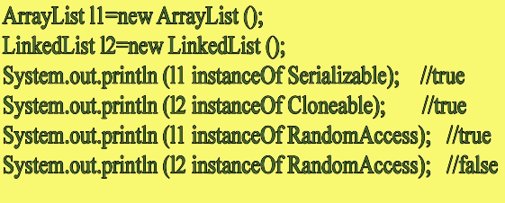

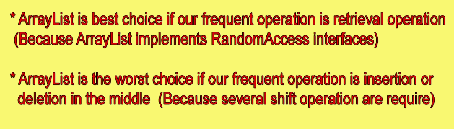

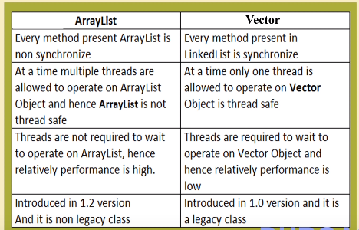

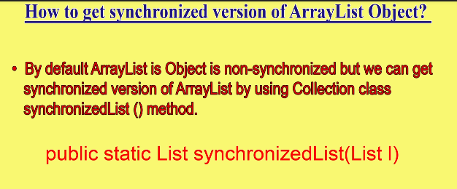

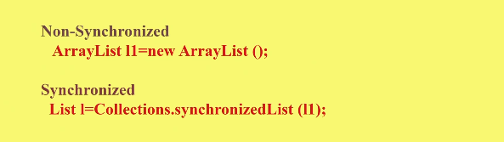

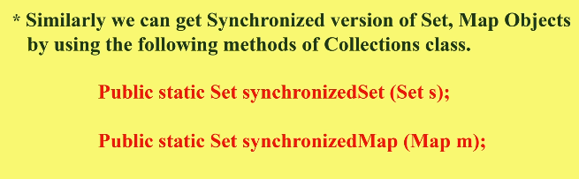

**Linked List:**

* If your requirement is insertion of elements or removal of elements from middle, then linkedlist is the best choice because there is no need of shift operations.
* For every search operation and retrieval of elements then linked list is the worst choice. Which reduces the performance.

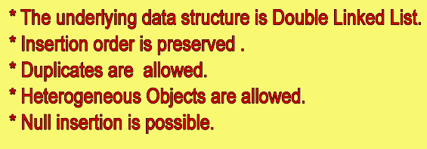

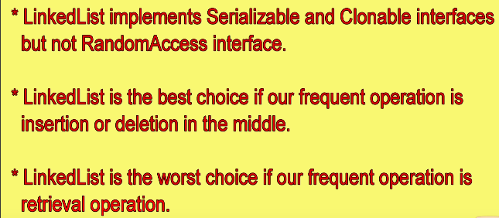

* Usually linked list implements stacks and queues here linked list implements Deque to get some specific methods.

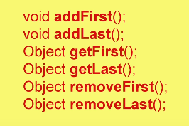

**Constructors:**

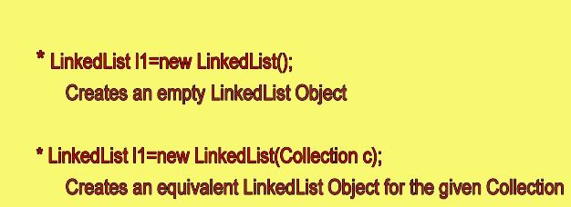

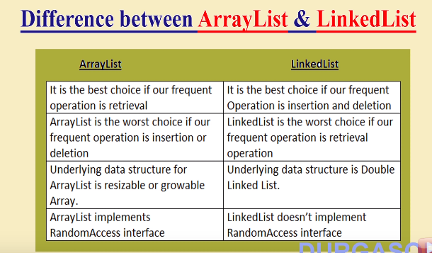

**Vector:**

* Underlying data structure is resizable array or growable array.
* Duplicates are allowed
* Insertion order is preserved.
* Null is allowed
* Heterogenous objects are allowed
* Implements all three serializable, cloneable, and RandomAccess.
* Synchronized (thread safe).

**Vector Specific methods:**

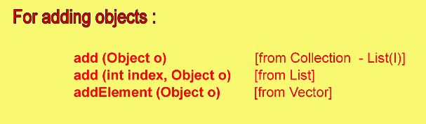

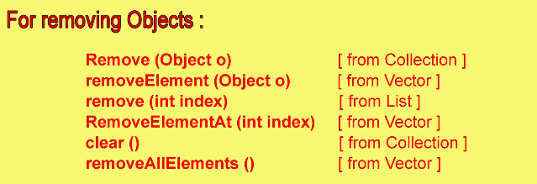

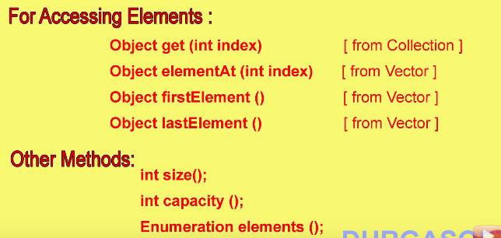

**Constructors:**

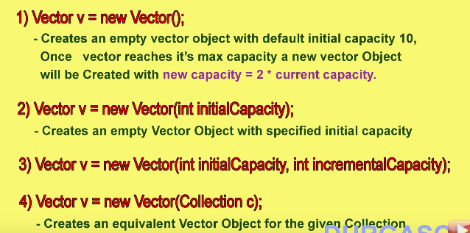

**Stack:**

* Child class of vector specially designed for LIFO.

**Constructor:**

* **Stack s = new Stack();**

**Methods specific to stack:**

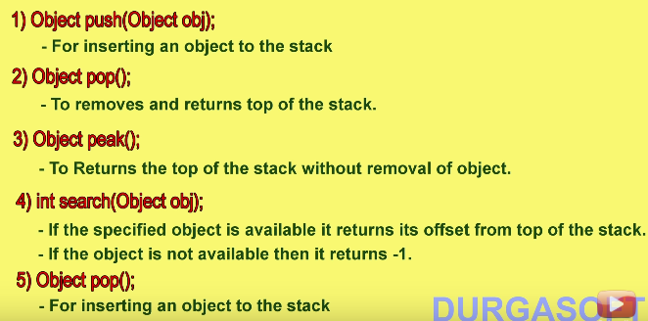

**Cursors in Java for Collections:** to retrieve objects one by one from collections.

1. **Enumeration:**

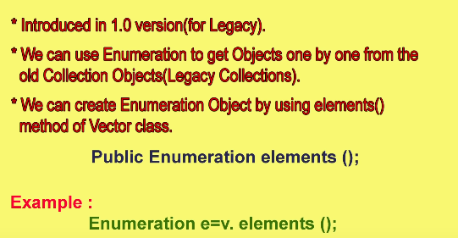

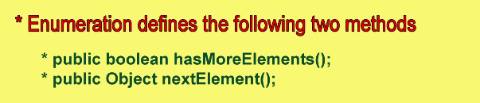

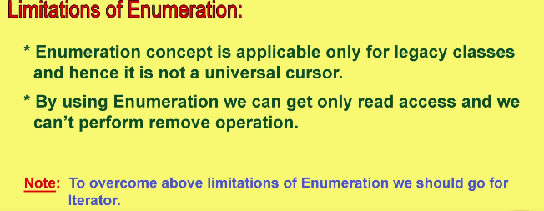

1. **Iterator:**
   * Universal cursor
   * Can perform **both read and remove operation.**
   * We can create iterator object by using the method iterator() of collection interface.

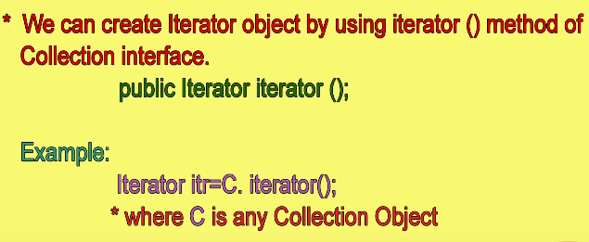

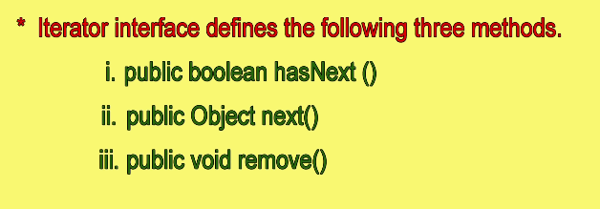

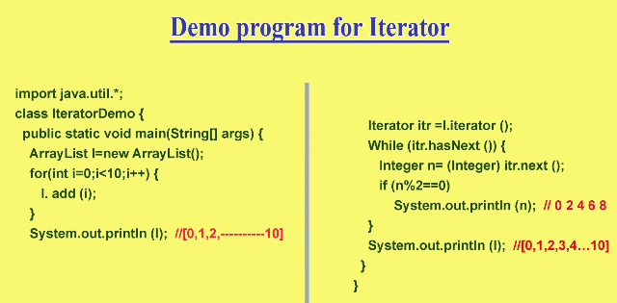

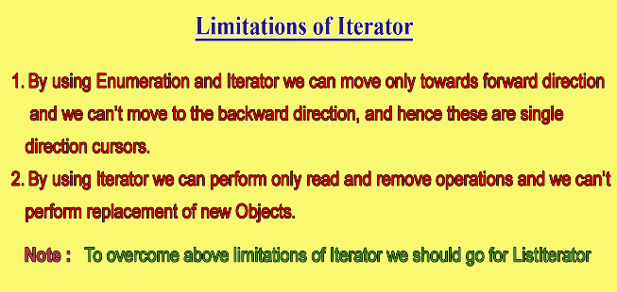

1. **ListIterator:**

* Bi-directional cursor.
* We can perform **read, remove, replacement and addition of new objects**.
* ListIterator implements Iterator.

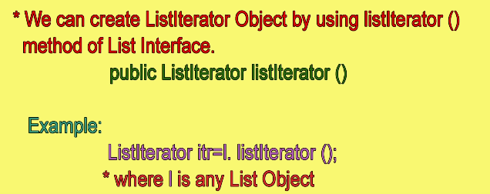

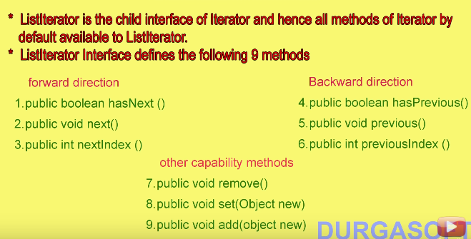

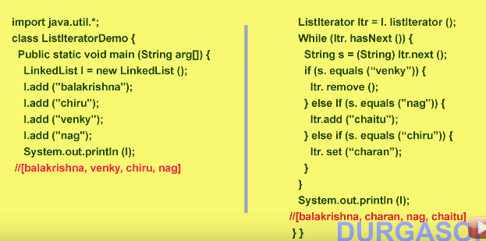

**The problem with ListIterator is it is applicable only to list implemented classes.**

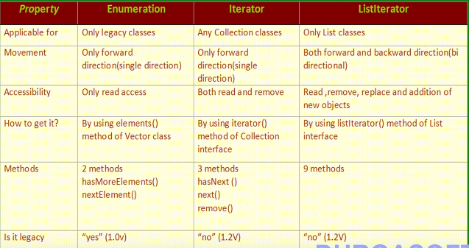

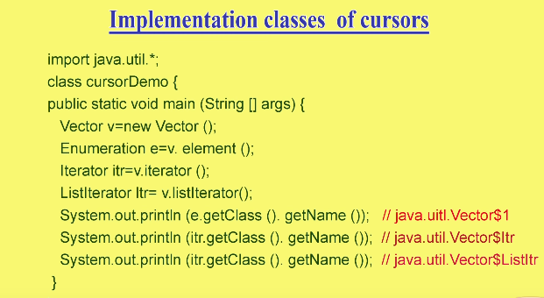

* Implementation class for Iterator interfaces is the inner classes inside the methods.

**Set(I):**

* Doesn’t define any new methods.

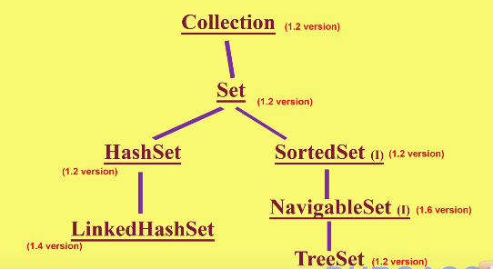

**HashSet:**

* Underlying DS is Hashtable.
* Insertion order is based on hash code of objects not preserved.
* Implements serializable and cloneable interfaces.
* Searching will be easy because of hashing.
* If our frequent operation is search, then HashSet is best choice.

**Constructors:**

* **HashSet h = new HashSet();**
  + Initial capacity is 16 and Fill ratio is 0.75.
  + **Fill ratio or Load factor** says when the hashset object has to get the new memory. Here h gets new memory when set is filled 75%.

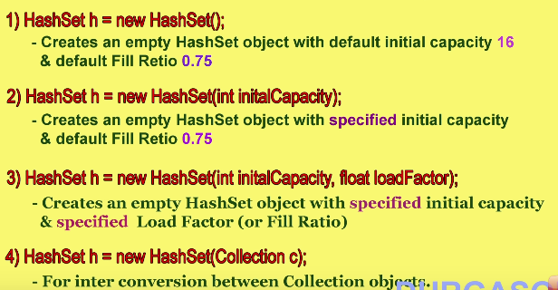

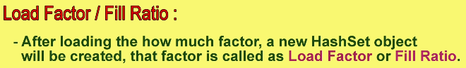

**Linked HashSet:**

* Child class of Hashset.
* Main difference between hashset and Linked hashset is insertion order is preserved.
* Underlying data structure is Hashtable + Linked list.

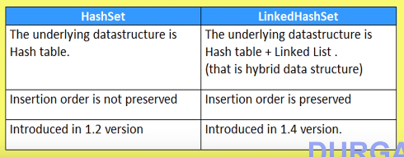

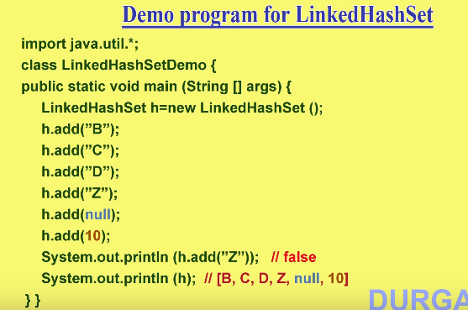

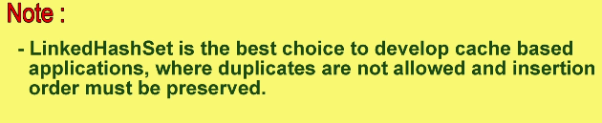

**SortedSet:**

* When we need represent group of objects according to some sorting order with no duplicates.

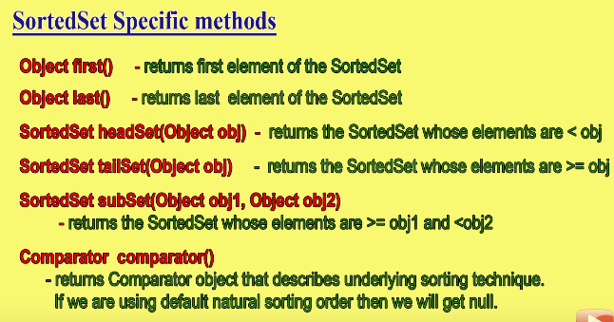

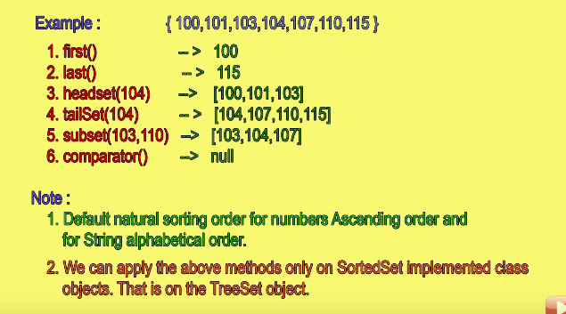

**Treeset:**

* Underlying data structure is Balanced Tree.
* Duplicates are not allowed.
* Insertion order is not preserved but objects are placed according to some sorting order.
* **Heterogenous objects are not allowed. (results in CCE)**
* Null is allowed but only once(as a first element)

**Constructors:**

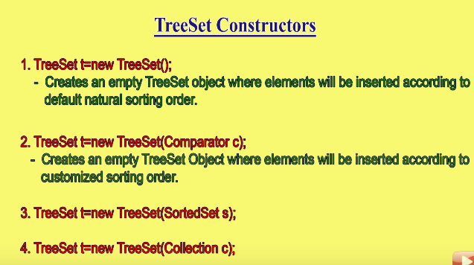

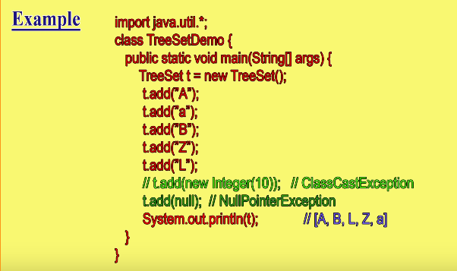

**Null Acceptance:**

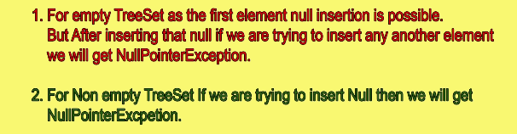

* **If we are depending on default natural sorting order (D.N.S.O) then the objects must be homogenous and comparable.**

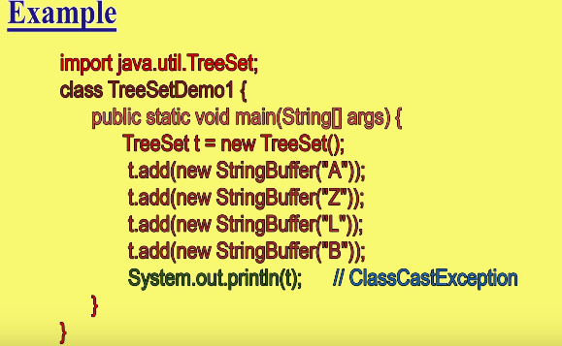

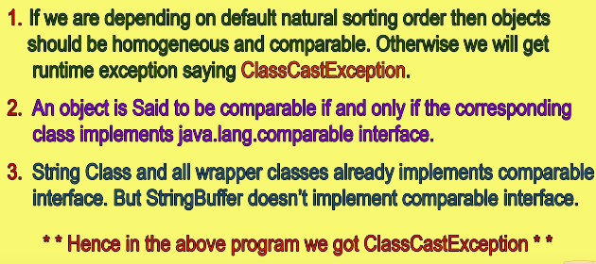

**Comparable(I):**

* Present in java.lang package and contains only one method “compareTo()”

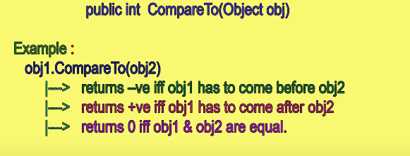

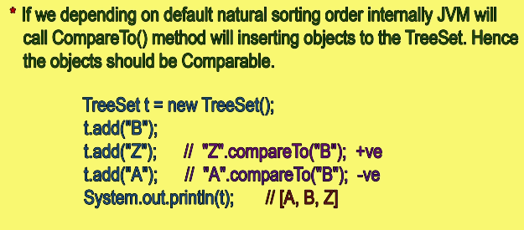

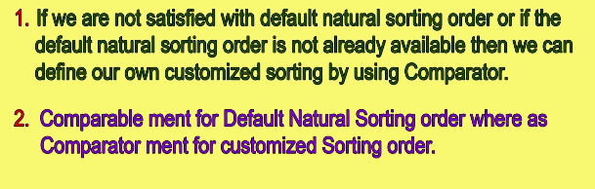

**Comparator(I):**

* Used when need of customized sorting order.
* In Java,Util Package
* Has two methods compare() and equals().

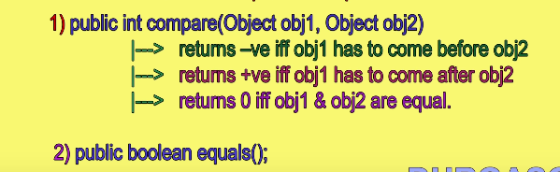

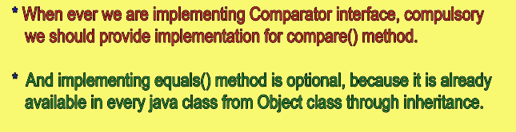

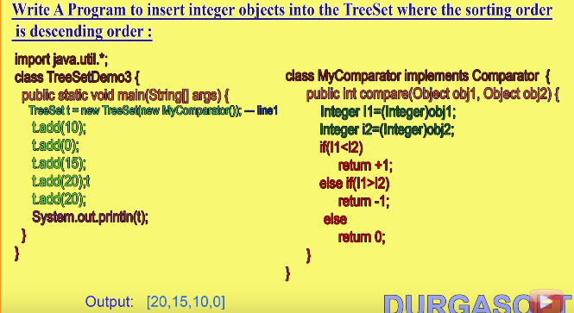

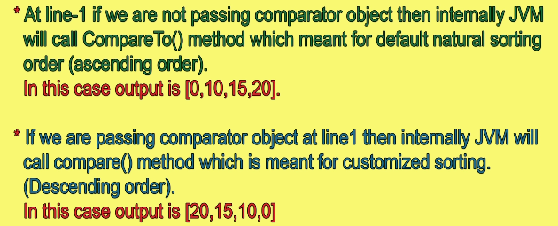

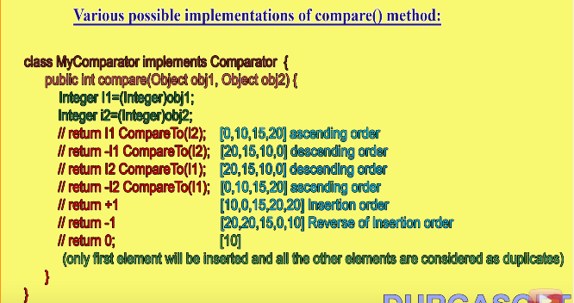

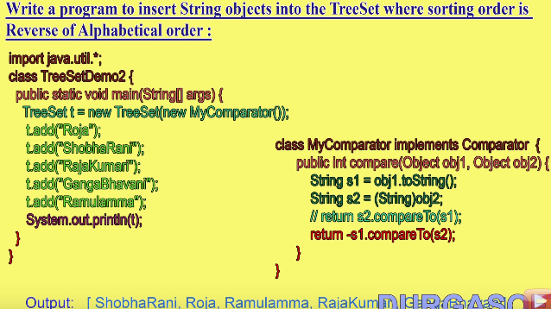

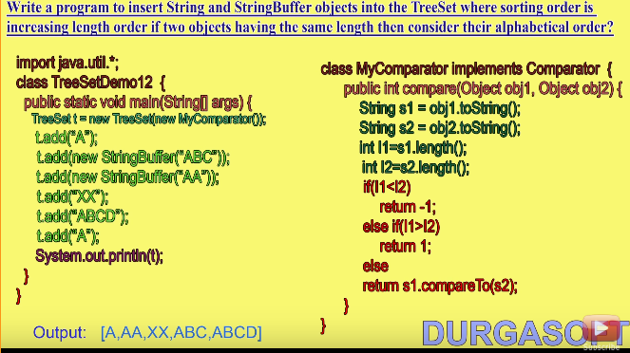

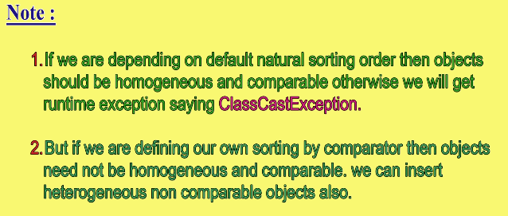

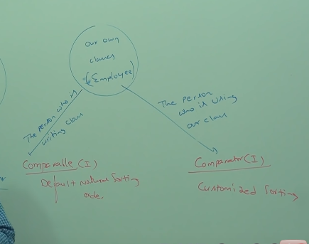

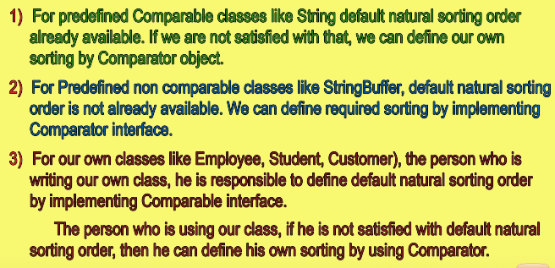

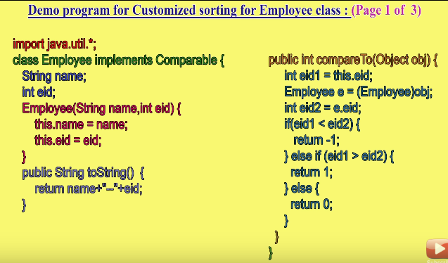

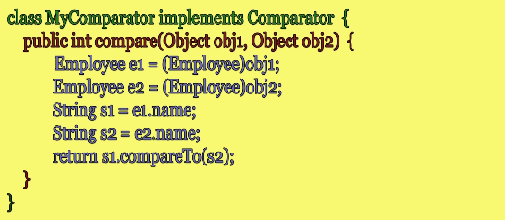

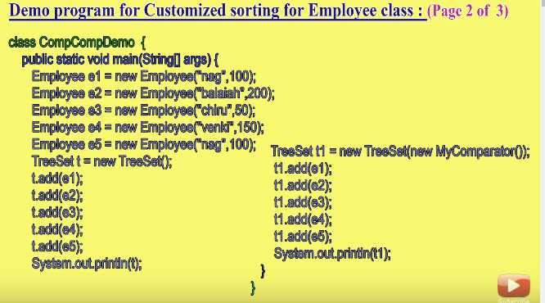

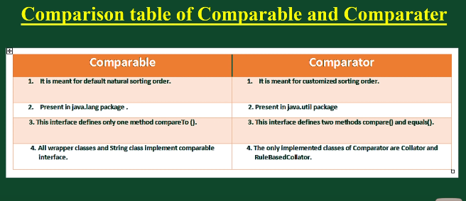

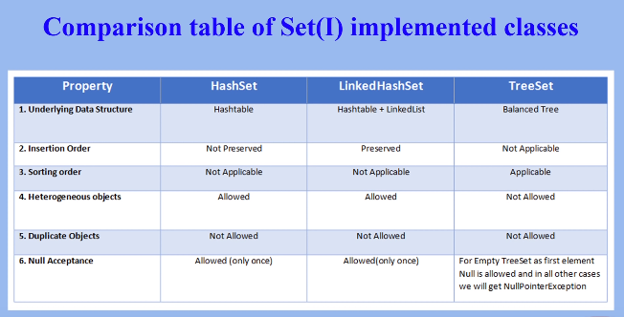

**Map(I):**

* If we want to represent a group of objects as key value pairs.
* Each key value pair is called Entry. So map is called a collection of entry objects.

**Methods in Map Interface:**

1. public Object **put(Object key, Object value)**: This method is used to insert an entry in this map.
2. public **void putAll(Map map**): This method is used to insert the specified map in this map.
3. public **Object remove(Object key**): This method is used to delete an entry for the specified key.
4. public **Object get(Object key)**:This method is used to return the value for the specified key.
5. public **boolean containsKey(Object key):** This method is used to search the specified key from this map.
6. public **boolean containsValue(Object Value):** This method is used to search the specified Value from this map.
7. **booelan isEmpty()**
8. public **Set keySet():** This method is used to return the Set view containing all the keys.
9. public **Set entrySet():** This method is used to return the Set view containing all the keys and values.
10. **Collection values()**
11. **int size()**
12. **void Clear()**

**Entry(I):**

* It is the inner Interface of the map Interface.
* It has 3 methods which can be applied on entry.

**Entry Specific Methods:**

* Object getKey()
* Object getValue()
* Object SetValue(Object newvalue)

**HashMap:**

* Underlying Ds is Hash table.
* Insertion order is not preserved, based on hashcode of keys.
* Duplicate keys are not allowed, but Duplicate values are allowed
* It allows Heterogenous objects for both key and value.
* Null is allowed for key only once
* Null is allowed for values any number of times.
* It implements Serializable and cloneable Interfaces.
* It is the best choice if our frequent operation is search operation.

**Constructors:**

**Same as Hashset constructors**

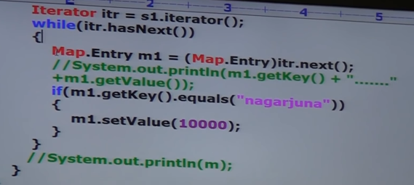

**HashMap and Hashtable:**

|  |  |
| --- | --- |
| **HashMap** | **Hashtable** |
| 1. Every method present in hash map is not synchronized | 1. Every method present in hash map is synchronized |
| 1. not thread safe | 1. Thread safe |
| 1. High performance | Low performance |
| 1. Null is allowed for both key and values | Null is not allowed |

**Synchronized version of Map:**

Map m1= Collections.synchronizedmap(m);

**Linked HashMap:**

* Child class of HashMap
* Underlying DS is Linked list + Hashtable
* Insertion order is preserved.
* Generally used for developing Cache based applications.

**Identity HashMap:**

* Generally Hashmap uses .equals method to find duplicate keys.
* Same as HashMap except in identity Hashmap it uses == operator to find the duplicate keys (means compares the reference)

**Weak HashMap:**

* It is exactly same as hashmap except the following difference
  + In case of hashmap even though object doesn’t have any reference, it is not eligible for GC if it is associated with hashmap. (HashMap dominates GC)
  + But in case of WeakHashMap if object doesn’t contain any references it is eligible for GC event though object is associated with WeakHashMap (GC dominates WeakHashMap)

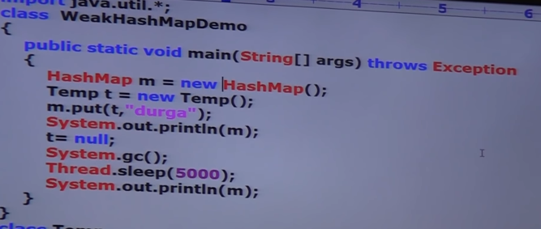

**SortedMap(I):**

* If we want add entries according some sorting order of keys.
* Methods are similar to sorted set.

**TreeMap:**

* Underlying DS is Red-Black Tree.
* Insertion order is not preserved, because it is based on hashcode.
* Duplicate keys are not allowed
* If we are depending on DNSO then keys should be homogenous and comparable otherwise we get CCE.
* If we are defining our own comparator by sorting keys need not be homogenous and comparable.
* Values has no restrictions.
* Constructors:
  + Same constructors as Treeset.

**Hashtable:**

* Null key and Null value are not allowed.
* We can override the hashcode method of a class to change the order of insertion.

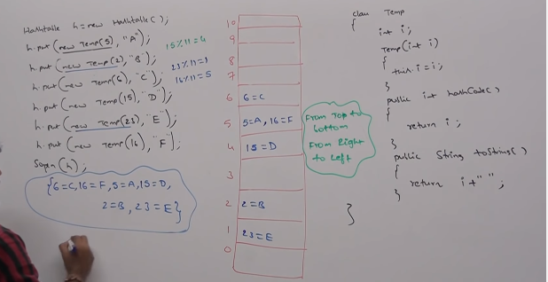

**Properties:**

* Both key and values should be strings.
* Methods:
  + String setProperty(String pname, String pvalue)
  + String getProperty(String pname)
  + Enumeration propertyNames()
  + To load and store properties between file.
    - Void load(InputStream is)
    - Void store(OutputStream os, String comment)

**Queue:**

* If we want to store something prior to processing.
* **FIFO**
* Child interface of collection

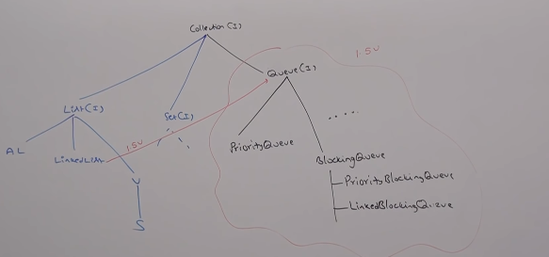

* Usually queue follows FIFO based on our requirement we can implement our own priority order also.
* Linkedlist based implementation of queue follows FIFO
* **Methods Specific to queue.**
  + Offer(Object 0) // add element queue
  + Poll() // remove head element of queue
  + Remove() // same as poll but when queue is empty then it gives NoSuchElementException
  + Peek() // gives head element
  + element() // same as peek but gives Exception when queue is empty.

**Priority Queue:**

* to process some group of elements prior to processing according to some priority.
* Priority can be DNSO or CSO
* Duplicates are not allowed.
* If we are depending on DNSO then objects should be Homogenous.
* Null is not allowed.

**Constructors:**

